**Modularity Report**

**Parameters:**

Randomize: On  
Use edge weights: Off  
Resolution: 1.0

**Results:**

Modularity: 0.412  
Modularity with resolution: 0.412  
Number of Communities: 22  
  
**Algorithm:**

Vincent D Blondel, Jean-Loup Guillaume, Renaud Lambiotte, Etienne Lefebvre, *Fast unfolding of communities in large networks*, in Journal of Statistical Mechanics: Theory and Experiment 2008 (10), P1000

**Resolution:**

R. Lambiotte, J.-C. Delvenne, M. Barahona *Laplacian Dynamics and Multiscale Modular Structure in Networks 2009*

**HITS Metric Report**

**Parameters:**

Ε = 1.0E-4

**Results:**

**Algorithm:**

Jon M. Kleinberg, *Authoritative Sources in a Hyperlinked Environment*, in Journal of the ACM 46 (5): 604–632 (1999)

**Modularity Report**

**Parameters:**

Randomize: On  
Use edge weights: On  
Resolution: 1.0

**Results:**

Modularity: 0.926  
Modularity with resolution: 0.926  
Number of Communities: 37  
  
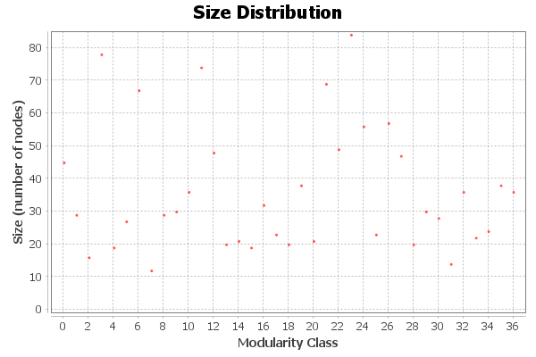

**Algorithm:**

Vincent D Blondel, Jean-Loup Guillaume, Renaud Lambiotte, Etienne Lefebvre, *Fast unfolding of communities in large networks*, in Journal of Statistical Mechanics: Theory and Experiment 2008 (10), P1000

**Resolution:**

R. Lambiotte, J.-C. Delvenne, M. Barahona *Laplacian Dynamics and Multiscale Modular Structure in Networks 2009*

**HITS Metric Report**

**Parameters:**

Ε = 1.0E-4

**Results:**

**Algorithm:**

Jon M. Kleinberg, *Authoritative Sources in a Hyperlinked Environment*, in Journal of the ACM 46 (5): 604–632 (1999)